Prompt 1: Initial Code Generation
Prompt:
Write a beginner-friendly C++ console program that generates random student excuses.
The program should ask the user to enter their name.
Store at least 10 excuse templates using a {name} placeholder.
Randomly select one excuse each time the program runs.
Replace {name} with the actual user input.
Handle empty input properly and display an error message.
Add comments in the code so beginners can understand it.

Code
#include <iostream>
#include <vector>
#include <cstdlib>
#include <ctime>
using namespace std;

// BUG: replaces only first occurrence
string personalize(string text, string name) {
size_t pos = text.find("{name}");
if (pos != string::npos) {
text.replace(pos, 6, name);
}
return text;
}

int main() {
string name;
cout << "Enter your name: ";
getline(cin, name);

if (name.empty()) {
cout << "Error: Name cannot be empty!" << endl;
return 0;
}

vector<string> excuses = {
"{name} couldn’t finish because {name}'s laptop crashed.",
"{name} tried submitting but {name}'s file disappeared.",
"{name}'s system froze while working.",
"{name} forgot to save the file.",
"{name}'s internet stopped working.",
"{name} accidentally deleted the file.",
"{name}'s computer restarted suddenly.",
"{name} faced a power cut.",
"{name} got logged out suddenly.",
"{name}'s keyboard stopped working."
};

srand(time(0));
int index = rand() % excuses.size();

cout << personalize(excuses[index], name) << endl;
return 0;
}

Ouput
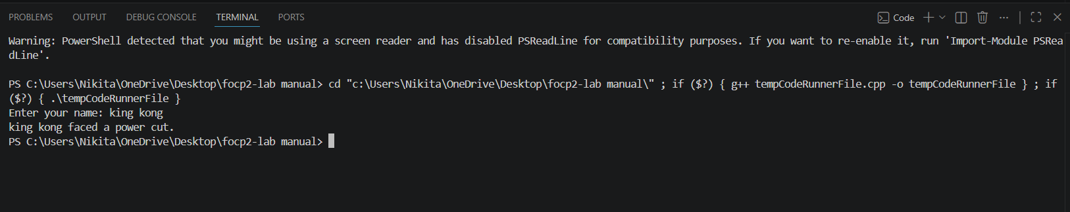

Prompt2:
Improve the previous program.
Make sure all occurrences of {name} are replaced.
Also make the code cleaner and more readable.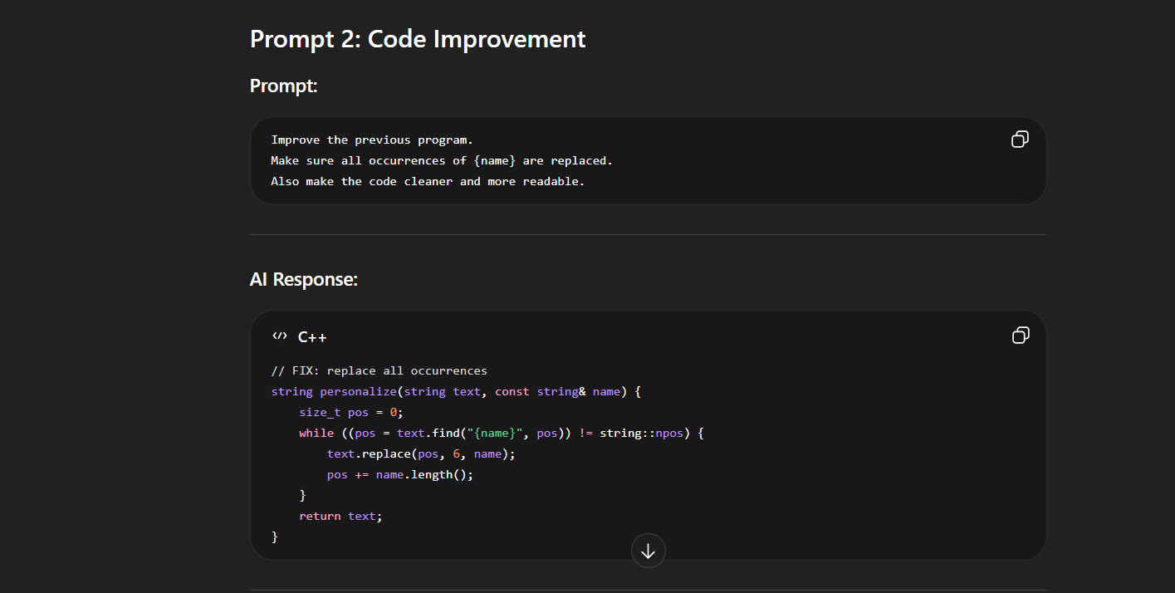
Code
#include <iostream>
#include <vector>
#include <cstdlib>
#include <ctime>
using namespace std;

// Improved function: replaces ALL occurrences of {name}
string personalize(string text, const string& name) {
size_t pos = 0;

// Loop to replace every occurrence
while ((pos = text.find("{name}", pos)) != string::npos) {
text.replace(pos, 6, name);
pos += name.length(); // Move forward after replacement
}

return text;
}

int main() {
string name;

// Take input from user
cout << "Enter your name: ";
getline(cin, name);

// Handle empty input
if (name.empty()) {
cout << "Error: Name cannot be empty!" << endl;
return 0;
}

// Excuse templates (with multiple {name})
vector<string> excuses = {
"{name} couldn’t finish because {name}'s laptop crashed.",
"{name} tried submitting but {name}'s file disappeared.",
"{name}'s system froze while {name} was working.",
"{name} forgot to save the file.",
"{name}'s internet stopped working when {name} was uploading.",
"{name} accidentally deleted the file.",
"{name}'s computer restarted suddenly.",
"{name} faced a sudden power cut.",
"{name} got logged out while {name} was submitting.",
"{name}'s keyboard stopped working during typing."
};

// Initialize random seed
srand(time(0));

// Select random excuse
int index = rand() % excuses.size();

// Personalize excuse
string finalExcuse = personalize(excuses[index], name);

// Display output
cout << finalExcuse << endl;

return 0;
}
Ouput

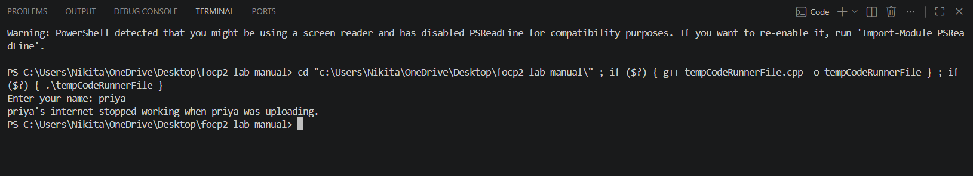
Prompt 3: Bug Identification
Prompt:
My program is not replacing {name} correctly in all cases.
Sometimes only one occurrence is replaced.
Why is this happening?
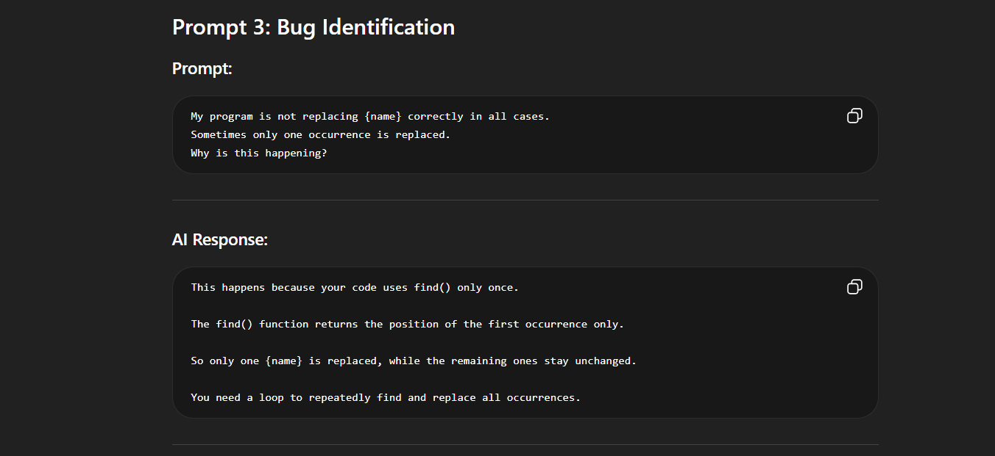

Prompt 4: Bug Fix Request
Prompt:
Fix the issue so that all occurrences of {name} are replaced correctly.
Explain the fix simply.

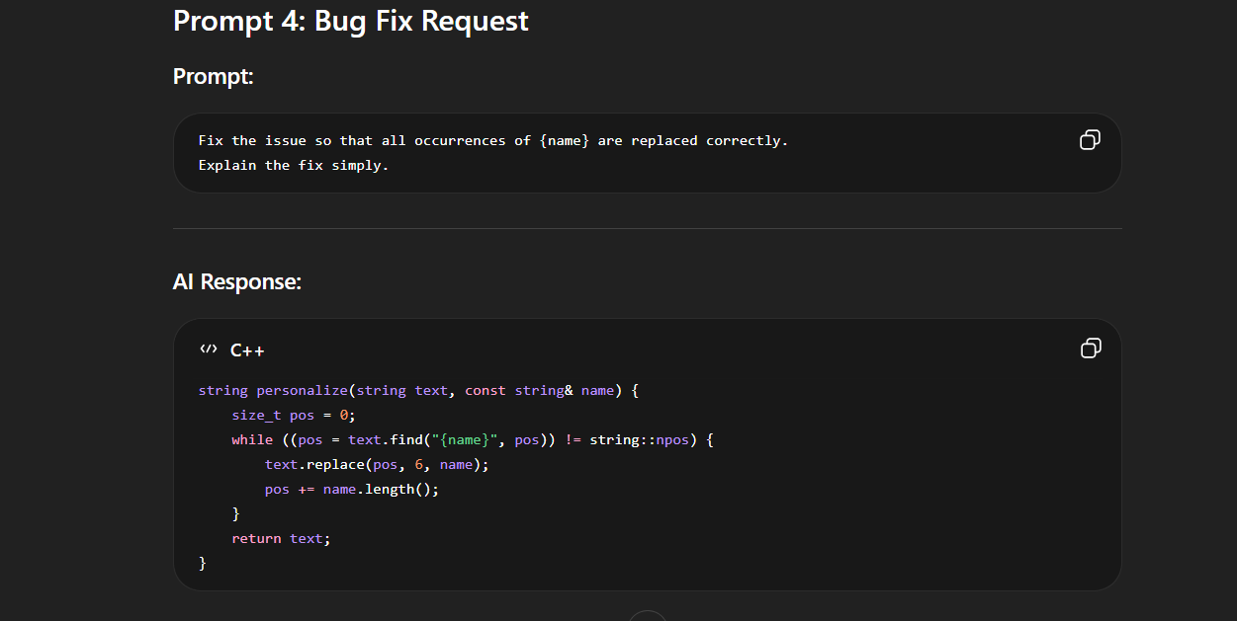Code
#include <iostream>
#include <vector>
#include <cstdlib>
#include <ctime>
using namespace std;

// FIXED FUNCTION (from Prompt 4)
string personalize(string text, const string& name) {
size_t pos = 0;

// Replace ALL occurrences of {name}
while ((pos = text.find("{name}", pos)) != string::npos) {
text.replace(pos, 6, name);
pos += name.length();
}

return text;
}

int main() {
string name;

// Take user input
cout << "Enter your name: ";
getline(cin, name);

// Handle empty input
if (name.empty()) {
cout << "Error: Name cannot be empty!" << endl;
return 0;
}

// Excuse templates
vector<string> excuses = {
"{name} couldn’t finish because {name}'s laptop crashed.",
"{name} tried submitting but {name}'s file disappeared.",
"{name}'s system froze while {name} was working.",
"{name} forgot to save the file.",
"{name}'s internet stopped working when {name} was uploading.",
"{name} accidentally deleted the file.",
"{name}'s computer restarted suddenly.",
"{name} faced a sudden power cut.",
"{name} got logged out while {name} was submitting.",
"{name}'s keyboard stopped working during typing."
};

// Initialize random generator
srand(time(0));

// Select random excuse
int index = rand() % excuses.size();

// Apply fix (replace all {name})
string finalExcuse = personalize(excuses[index], name);

// Output result
cout << finalExcuse << endl;

return 0;
}
Output
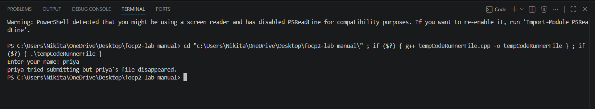
FINAL CODE
#include <iostream>
#include <vector>
#include <cstdlib>
#include <ctime>
using namespace std;

string personalize(string text, const string& name) {
size_t pos = 0;
while ((pos = text.find("{name}", pos)) != string::npos) {
text.replace(pos, 6, name);
pos += name.length();
}
return text;
}

int main() {
string name;
cout << "Enter your name: ";
getline(cin, name);

if (name.empty()) {
cout << "Error: Name cannot be empty!" << endl;
return 0;
}

vector<string> excuses = {
"{name} couldn’t finish because {name}'s laptop crashed.",
"{name} tried submitting but {name}'s file disappeared.",
"{name}'s system froze while working.",
"{name} forgot to save the file.",
"{name}'s internet stopped working.",
"{name} accidentally deleted the file.",
"{name}'s computer restarted suddenly.",
"{name} faced a power cut.",
"{name} got logged out suddenly.",
"{name}'s keyboard stopped working."
};

srand(time(0));
int index = rand() % excuses.size();

cout << personalize(excuses[index], name) << endl;
return 0;
}
OUTPUT
